Bradley De Ath

DEA18001355

3D Visualisation and Interacion design

SCDT45 – Assignment One

Table of Contents

Introduction 3

Specifications 3

Interactivity 3

Navigate the Information 3

Chemistry: Simple Compounds 4

Chemistry & Physics: Information Separation: 4

The Layout of the Experience 4

The Main Menu 4

The Biology Branch 5

The Chemistry Branch 6

The Physics Branch 7

The Interaction and Justification 8

Bibliography 9

# Introduction

I have been tasked with designing an interactive 3D experience for secondary school students to help further their education in science, as well as allow them to learn important information in a different way from the standard form of teaching. This report will go over my designs for this system along with the details for what is required and how it will be achieved.

# Specifications

Identifying and understanding the requirements are important in making sure that what the client’s vision for the system is met. Without this, then the design will likely end up not being what is needed and so would be unsatisfactory. This section of the report will go over the requirements that I have identified, as well as what the impact they will have on the overall design of the system.

## Interactivity

The first requirement for this system is that is interactive. While there can be systems that allow for students to observe important information in a 3D space, the ability to simply view it is not the intention of this experience. It is clearly laid out by the client that the students who will be using this system will need to be able to interact with and modify the 3D displays. Without interactivity in this experience, then the students would gain no additional benefits from using the system, when compared to YouTube videos or other common forms of information sharing. This requirement is the basis for the entirety of the experience, and so without it the system would be lacking the usage that the client is looking for.

## Navigate the Information

With the range of information being presented to users within this experience, being able to properly manage and navigate between it is important. As there is information related to multiple science branches within this experience, having all of it presented to the user simultaneously can be overwhelming and could end up taking away from the overall design. As stated in Hick’s Law, the more choices that a user is presented with, the harder it becomes for them to make their decision **(Proctor and Schneider, 2018)**. This means that were all of the information contained in this experience to be displayed to the user at once, then there would be too much for them to allow them to properly take in what each branch contains.

Taking this requirement into consideration, I have decided to implement a user interface containing Menus and buttons to allow the user to properly navigate through the system. With the ability to specifically view each branch of the experience, then the amount of information and options presented to the user can be reduced, and so helps prevent them being overwhelmed.

## Chemistry: Simple Compounds

For the chemistry branch of the experience a requirement for the type of information available is laid out. This is for the compounds that the users can interact with to be “Common Compounds”. It is stated in the brief that the users of this experience are Middle School Students. This means that were the compounds included in this system to be too complicated, then it would not be beneficial for the students using it.

## Chemistry & Physics: Information Separation:

Another of the requirements for the chemistry branch of the experience is for there to be more than one compound available to the user. As mentioned previously, I have decided to use menus to properly divide up the information available in the experience as to not overwhelm the user. This division also applies to within the branches themselves, as the user will be able to use buttons to toggle between the compound that is currently being displayed and the second one that would not be visible.

This same segregation will also apply to the circuits that the user can interact with in the Physics branch of the experience. It is stated in the brief that the user can view and interact with 3D representations of both “Series” and “Parallel” electrical circuits. The previously mentioned method of organisation is used here, with a user interface containing buttons being used to allow the user to navigate between the circuit types available. This same method also applies to the chemistry branch, as the different compounds are also able to be accessed through the use of a button on each of the Chemistry scenes.

This requirement is important to the design of the system, as without it there would be key information left unavailable to the students. Were both compounds/circuit types not included in the experience, then the students would be left lacking the ability to interact with a crucial part of the system. This would cause the experience to be incomplete and so would be detrimental to the design quality of the experience.

# The Layout of the Experience

## The Main Menu

Upon the initial opening of the science experience, the user is greeted with the main menu of the software. As can be seen in the wireframe above, the main menu is divided until easily identifiable sections for each of the branches.

When designing the main menu, I made sure to consider the principle of limiting the number of actions that need to be completed by a user to achieve a task **(Babich, n.d.)**. This can be seen in the wireframe where each branch of science has the ability to access the different areas without the need of a sub-menu for each separate branch. Were these menus to be included, then every time a user tried to navigate to those branches, they would have to navigate more interfaces. For example, the physics branch of the experience has buttons to access both “Series Circuits” and “Parallel Circuits” scenes from the main menu.

Outside of the main menu interface, each branch has a button separate to the ‘exit’ button that allows them to return directly to the main menu, this avoids the need to completely exit the software in order to load a different branch of the experience. This makes the process of switching between branches more efficient/ easier.

## The Biology Branch

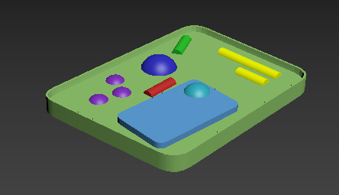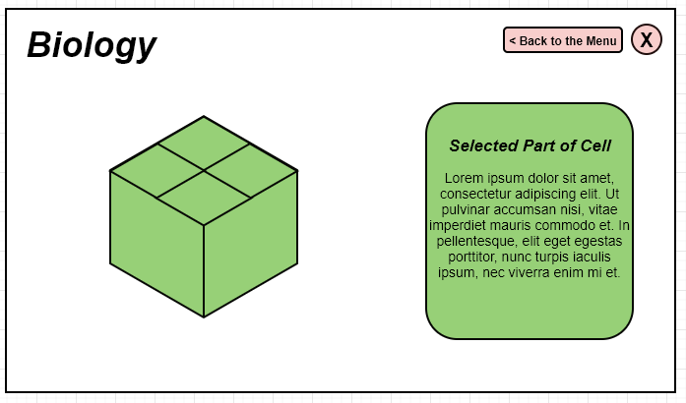

As was laid out in the Brief for this science experience, the content of the Biology branch revolves around the anatomy of a plant cell: with the user being able to see and interact with the different components that make up the overall structure. Through mouse clicking on each of the different components, the information relating to the corresponding part of the cell is displayed for the user to read. As can be seen in the wireframe above, the display for the information is a pop-up to the side of the 3D model and so doesn’t limit the cell’s visibility to provide the information to the student.

## The Chemistry Branch

For the chemistry branch of the experience, users are able to view and interact with 3D representations of common chemical compounds. As can be seen in the above wireframes, the compounds are displayed in their molecular structures, with each molecule for the chemicals being easily identifiable through use of letters and colours. The students are able to interact with and select each molecule individually, which similarly to the components of the cell anatomy, will display a pop-up to the side with the relevant information for that chemical. Furthermore, users are also able to rotate the models of the compounds on the screen. This allows them to have a proper view of all of the chemicals making up the structure, preventing the potential loss of being able to see the components, as molecular structures can branch in a range of directions.

## The Physics Branch

As can be seen in the brief, the physics branch of the experience shows two both series and parallel circuits. For my interpretation, the user is able to toggle the switches within these circuits to see the effects on the wires and components that are present. Once the switches have been powered on, the change of state can be seen through different visual effects on the user’s interface. Where power is present, the “wiring” that makes up the circuits will change colour from black to red, with the lights also having a yellow colouring to signify that they are on. Along with these, a part of the switch itself will also change colour depending on its power state – with green for “on” and “red” for off.

As well as the object colour, the lighting feature is also toggled accordingly. This creates an accurate effect of lighting in the scene once the power is on, I chose to use this as it provides a stronger visualisation of the impact of the user’s actions when coupled with the colour change.

The power state is changed through the user pressing the “Space” Key on their keyboard. To avoid any potential confusion or mistakes, it is displayed to the user on the interface which key needs to be pressed to toggle the change.

## The Interaction and Justification

Making sure that the design of the experience is both user friendly and correct is important. If the user is unable to find and use the content they are using the software for, or the important content is simply missing from the system entirely, then it will make the entire Science Experience unnecessary and near unusable. There were several aspects of the software I had to consider to ensure that I did not make the same mistakes.

As can be seen in the above use case for the experience, each branch of science has its own ways of being interacted with, being kept separate from each of the other branches. I chose to do this for the experience as it helps keep each of the science branches separate. It is important for only relevant information to be displayed to the user **(Galitz, n.d.)**, as otherwise users may attempt to interact with content tat is not related to what they are viewing – and so be confused when it doesn’t work. For example, students who are viewing the plant cell in the biology branch, don’t need the information relating to toggling the power options for the Physics Branch

The interaction method for the Biology branch is the use of Mouse Clicks. As there is a large amount of content that make up the anatomical structure of the plant cell, keeping the interaction simple helps to avoid overcomplicating processes and confusing the user. While providing a user with several ways of interacting with the system can be helpful, going overboard and proving too many can be detrimental to the usability of the experience. This is because the user can become overwhelmed by choice and so have a harder time finding the interaction method that applies to what they need.

The interaction for the Chemistry branch is similar to the Biology, being able to click on each of the chemicals that make up the compounds to get more information on them. But on top this, users are also able to rotate the models of the compounds on the screen. This allows them to have a proper view of all of the chemicals making up the structure, preventing the potential loss of being able to see the components, as molecular structures can branch in a range of directions. I chose to keep the method of interaction similar as to avoid potential confusion for the students. It has been recorded that having interfaces be inconsistent in design can lead to mistakes by users **(Rhee, Moon and Choe, 2006)**, and so can make the entire system less user friendly.

For the Physics branch of the experience, the students interact with the circuit representations through key presses. Instead of being able to use the mouse to click on the switches to toggle the power, users can press the Space Bar on their keyboard to toggle, keeping the interaction simple and avoiding making any potential mistakes. As the user only needs to interact with a single component of the circuit (The Switch), having them need to navigate and click to toggle it could result in confusion over which component needs to be used and so mistakes being made.

An important principle to consider in Interface design is Emotional Interaction **(Preece., Rogers. and Sharp., 2019)**. This is where how a user may be feeling as a result of using the product and using that in adjusting the overall design. With this Science Experience being used within a school, students will be under both pressure from time and staff to understand the information within this experience. If the design is too inefficient or complicated to use, then the student may be come stressed at their inability to complete their needed task. Using emotional interaction, I made sure to keep the different elements and objects that a student would be interacting with simple and easily identifiable. This can be seen in the Biology branch, where the cell itself and the items that make up its anatomy easy to identify apart from each other.

# Bibliography

Babich, N. (n.d.). *The 4 Golden Rules of UI Design | Adobe XD Ideas*. [online] Ideas. Available at: https://xd.adobe.com/ideas/process/ui-design/4-golden-rules-ui-design/ [Accessed 19 Feb. 2020].

Galitz, W. (n.d.). *The Essential Guide to User Interface Design*. John Wiley & Sons, p.507.

Preece., J., Rogers., Y. and Sharp., H. (2019). *Interaction design*. Indianapolis: Wiley.

Proctor, R. and Schneider, D. (2018). Hick’s law for choice reaction time: A review. *Quarterly Journal of Experimental Psychology*, 71(6), pp.1281-1299.

Rhee, C., Moon, J. and Choe, Y. (2006). Web interface consistency in e‐learning. *Online Information Review*, 30(1), pp.53-69.